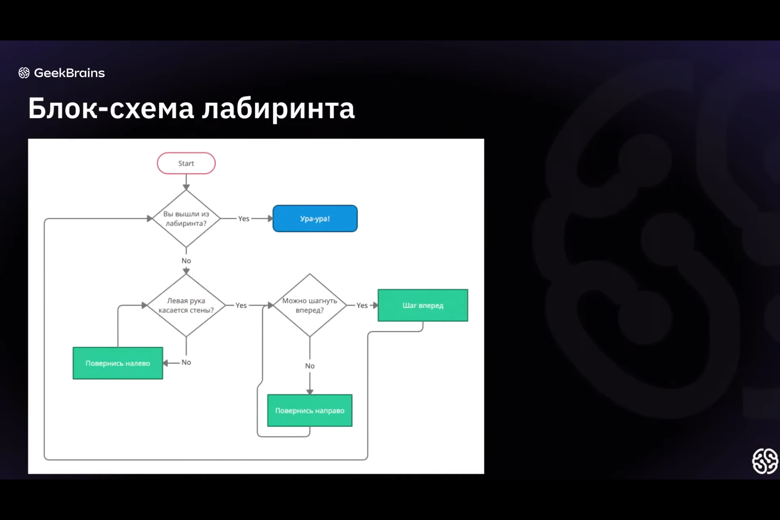

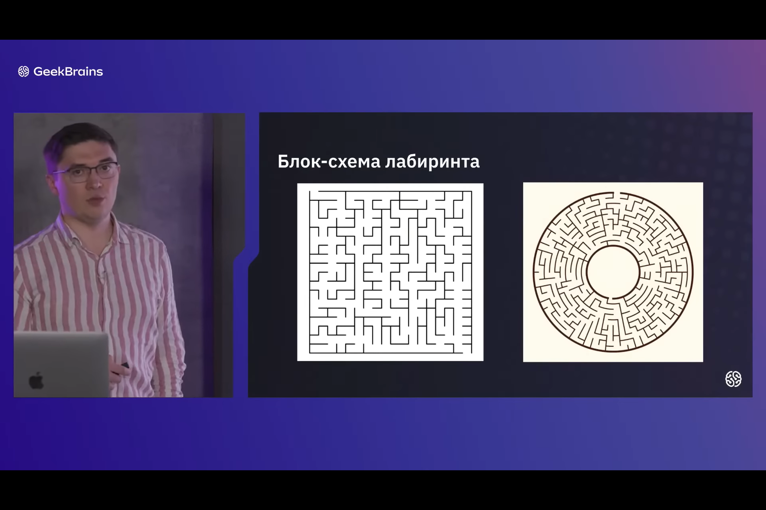

S-(Uc\*Tc+U2\*T2)=S1; S1=0 Yes No

N=1 S1-(Uc\*Tc+U1\*T1+U2\*T2)=S2; S2=0

n=2 S2-(Uc\*Tc+ U1\*T1+U2\*T2)=S3; S3=0